**Unit 2: Working in Health and Social Care**

**Work to complete for 1st lesson**

**September 2020**



**Name: ________________**

**Working in Health and Social Care**

Health care is

Social care is

Roles are

Responsibilities are

**Your task is to investigate the roles and responsibilities of all of the following Health or social care workers.**

|  |  |  |  |
| --- | --- | --- | --- |
| **Health and social care workers** | **Completed** | **Checked by Mrs Garratt** | **Further work required** |
| **Nurse** |  |  |  |
| **Doctor** |  |  |  |
| **Midwife** |  |  |  |
| **Healthcare Assistant** |  |  |  |
| **Occupational Therapist** |  |  |  |
| **Physiotherapist** |  |  |  |
| **Social worker** |  |  |  |
| **Youth worker** |  |  |  |
| **Support worker** |  |  |  |
| **Care manager** |  |  |  |
| **Care assistant** |  |  |  |

**Nurse**

[](https://www.google.co.uk/url?sa=i&source=images&cd=&cad=rja&uact=8&ved=2ahUKEwjCifWZqqvbAhXIVBQKHT5QArgQjRx6BAgBEAU&url=http://scrubsmag.com/you-know-you-are-a-pediatric-nurse-when/&psig=AOvVaw2zCV-1DjH7AeX7mWMabpMC&ust=1527697287491815)

**What is the role of a nurse?**

**What are the responsibilities of a nurse?**

**Doctor**

[](https://www.google.co.uk/url?sa=i&source=images&cd=&cad=rja&uact=8&ved=2ahUKEwjOtPTKqqvbAhUMvxQKHSHsDTUQjRx6BAgBEAU&url=https://dermamedical.co.uk/junior-doctors-could-training-in-aesthetics-be-the-answer-you-are-looking-for/&psig=AOvVaw3mSNy2tDGo8Rza5_FycU06&ust=1527697393217196)

**What is the role of a doctor?**

**What are the responsibilities of a doctor?**

**Midwife**

[](https://www.google.co.uk/url?sa=i&source=images&cd=&cad=rja&uact=8&ved=2ahUKEwjg_PSLq6vbAhVE6RQKHb8XBJgQjRx6BAgBEAU&url=https://nortonhealthcare.com/news/what-is-a-midwife&psig=AOvVaw0dC8P880RN4x5u-6wf44yi&ust=1527697534943831)

**What is the role of a midwife?**

**What are the responsibilities of a midwife?**

Meet the professionals – Homework 1 week 1

Set on:

**Healthcare Assistant**

**Healthcare Assistant**

[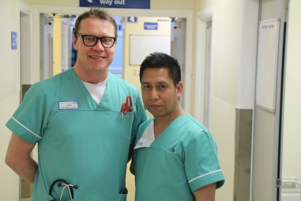](https://www.google.co.uk/url?sa=i&source=images&cd=&cad=rja&uact=8&ved=2ahUKEwi45bPNq6vbAhUGcRQKHZrcBUkQjRx6BAgBEAU&url=https://www.nth.nhs.uk/news/new-apprenticeships-are-helping-healthcare-assistants/&psig=AOvVaw3rwwich1YiC0hUU8225gzR&ust=1527697698485193)

**What is the role of a healthcare assistant?**

**What are the responsibilities of a healthcare assistant?**

Meet the professionals – Lesson 2 week 1

**Occupational Therapist**

[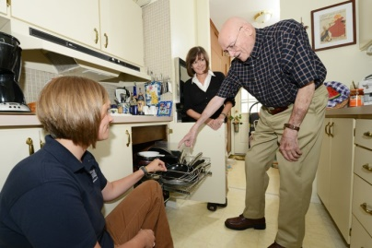](https://www.google.co.uk/url?sa=i&source=images&cd=&cad=rja&uact=8&ved=2ahUKEwj-i5GGrKvbAhULuBQKHfowDAYQjRx6BAgBEAU&url=https://www.sherrardlaw.com/single-post/2017/06/29/Home-Modifications-and-Occupational-Therapy&psig=AOvVaw1LbJRRh3-6eU9QE7n4y5W7&ust=1527697821681729)

**What is the role of an occupational therapist?**

**What are the responsibilities of an occupational therapist?**

**Physiotherapist**

[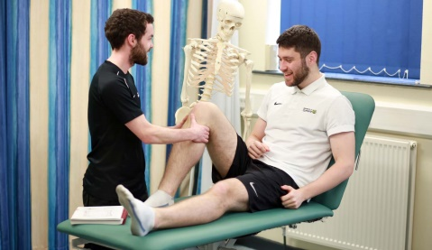](https://www.google.co.uk/url?sa=i&source=images&cd=&cad=rja&uact=8&ved=2ahUKEwig15ukrKvbAhWH1xQKHdv1A_4QjRx6BAgBEAU&url=http://www.cumbria.ac.uk/study/courses/undergraduate/physiotherapy/&psig=AOvVaw1SEuV9nH8DICG6tqfBMHA2&ust=1527697880682359)

**What is the role of a physiotherapist?**

**What are the responsibilities of a physiotherapist?**

**Social Worker**

[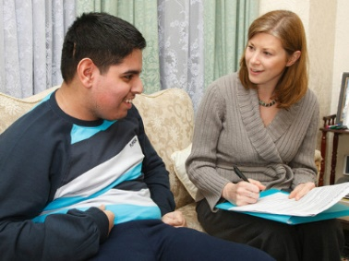](https://www.google.co.uk/url?sa=i&source=images&cd=&cad=rja&uact=8&ved=2ahUKEwjcyNfDrKvbAhUDnRQKHTRZAo0QjRx6BAgBEAU&url=http://www.communitycare.co.uk/2016/02/11/care-act-drives-surge-demand-social-workers-thousands-posts-go-unfilled/&psig=AOvVaw2uOhhUHntpbI90GeIKhzci&ust=1527697943258271)

**What is the role of a social worker?**

**What are the responsibilities of a social worker?**

Meet the professionals – Lesson 2 week 1

**Youth Worker**

[](https://www.google.co.uk/imgres?imgurl=http://www.liftislington.org.uk/media/1175/liftyouthworkers.jpg?width=640&center=0.5,0.5&mode=crop&imgrefurl=http://www.liftislington.org.uk/support/lift-youth-workers&docid=vcx0q7GNFilvwM&tbnid=lzKrE_nk7s4qCM:&vet=10ahUKEwj-5KSJrqvbAhUKVsAKHemaBmQQMwh0KB0wHQ..i&w=640&h=427&bih=963&biw=1920&q=youth%20worker&ved=0ahUKEwj-5KSJrqvbAhUKVsAKHemaBmQQMwh0KB0wHQ&iact=mrc&uact=8)

**What is the role of a youth worker?**

**What are the responsibilities of a youth worker?**

**Support Workers**

**[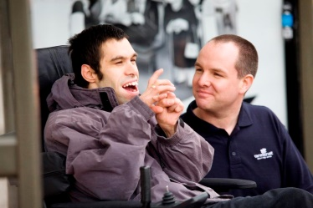](https://www.google.co.uk/url?sa=i&source=images&cd=&cad=rja&uact=8&ved=2ahUKEwjaz7axrqvbAhWLuBQKHY4rD-MQjRx6BAgBEAU&url=http://www.crossroads-leavalley.org.uk/about-us/photo-gallery/&psig=AOvVaw3TnJKweTbmCQo0qyf7qAMk&ust=1527698442755516)**

**What is the role of a support worker?**

**What are the responsibilities of a support worker?**

**Care Manager**

[](https://www.google.co.uk/url?sa=i&source=images&cd=&cad=rja&uact=8&ved=2ahUKEwit5IjdrqvbAhWIyRQKHd_FAUAQjRx6BAgBEAU&url=http://www.waypoints-care.co.uk/verwood-gallery.html&psig=AOvVaw2nPrKOATh-Nnp4ot6zM8zD&ust=1527698544246086)

**What is the role of a Care manager?**

**Care Assistant**

**What are the responsibilities of a Care manager?**

[](https://www.google.co.uk/url?sa=i&source=images&cd=&cad=rja&uact=8&ved=2ahUKEwilg5mJr6vbAhUDkRQKHWKDBF4QjRx6BAgBEAU&url=http://www.icarenursingservices.com/home-health-care-personal-care&psig=AOvVaw2QDn-nlewfIIddvcDdwksT&ust=1527698612400299)

**What is the role of a Care Assistant?**

**What are the responsibilities of a Care Assistant?**